> library(readr)
> library(dplyr)
> library(ggplot2)
> library(stringr)
> library(tidyr)
> sd <- read_csv("datasets/sensitivity runs/LTG_Sensitivity.csv")
Rows: 100 Columns: 203
── Column specification ────────────────────────────────────────────────
Delimiter: ","
dbl (203): Year, ="Run 1: Population", ="Run 2: Population", ="Run 3...

ℹ Use `spec()` to retrieve the full column specification for this data.
ℹ Specify the column types or set `show_col_types = FALSE` to quiet this message.
> sd_tidy <- sd %>%
+ pivot_longer(cols=!Year,names_to="Variable",values_to="Value") %>%
+ mutate(Variable=str_replace_all(Variable,'\"',""),
+ Variable=str_replace(Variable,"=","")) %>%
+ separate(Variable,into=c("Run","Variable"),sep = ":") %>%
+ mutate(Variable=trimws(Variable)) %>%
+ separate(Run,c("TempRun","Run"),sep = " ",convert = TRUE) %>%
+ select(Run,Year,Variable,Value)
> ggplot(filter(sd_tidy,Variable=="Population"),
+ aes(x=Year,y=Value,group=Run))+geom_line()

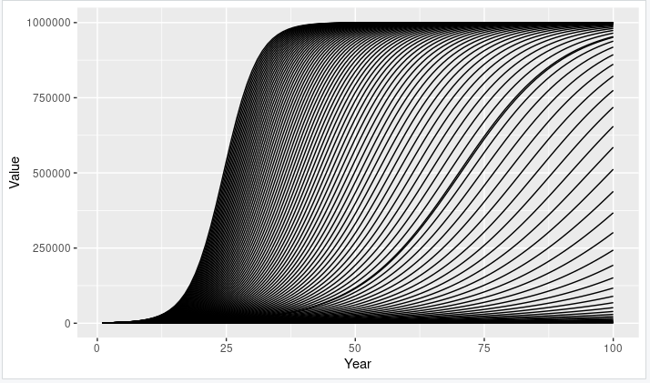

> sum_runs <- sd_tidy %>%
+ filter(Variable=="Population") %>%
+ group_by(Variable,Year) %>%
+ summarise(Q75=quantile(Value,0.75),
+ Q25=quantile(Value,0.25),
+ Median=median(Value),
+ Mean=mean(Value))
`summarise()` has grouped output by 'Variable'. You can override using
the `.groups` argument.
> ggplot(sum_runs,aes(Year, Median)) +
+ geom_ribbon(aes(ymin = Q25,ymax = Q75),fill = "steelblue2") +
+ geom_line(color = "firebrick")

